**PL/SQL EXERCISES**

**Exercise 3: Stored Procedures**

**Scenario 1:** The bank needs to process monthly interest for all savings accounts.

* + **Question:** Write a stored procedure **ProcessMonthlyInterest** that calculates and updates the balance of all savings accounts by applying an interest rate of 1% to the current balance.

**Scenario 2:** The bank wants to implement a bonus scheme for employees based on their performance.

* + **Question:** Write a stored procedure **UpdateEmployeeBonus** that updates the salary of employees in a given department by adding a bonus percentage passed as a parameter.

**Scenario 3:** Customers should be able to transfer funds between their accounts.

* + **Question:** Write a stored procedure **TransferFunds** that transfers a specified amount from one account to another, checking that the source account has sufficient balance before making the transfer.

**IMPLEMENTATION IN LIVE SQL :**

**Creation of Tables and Data stored in Database:**

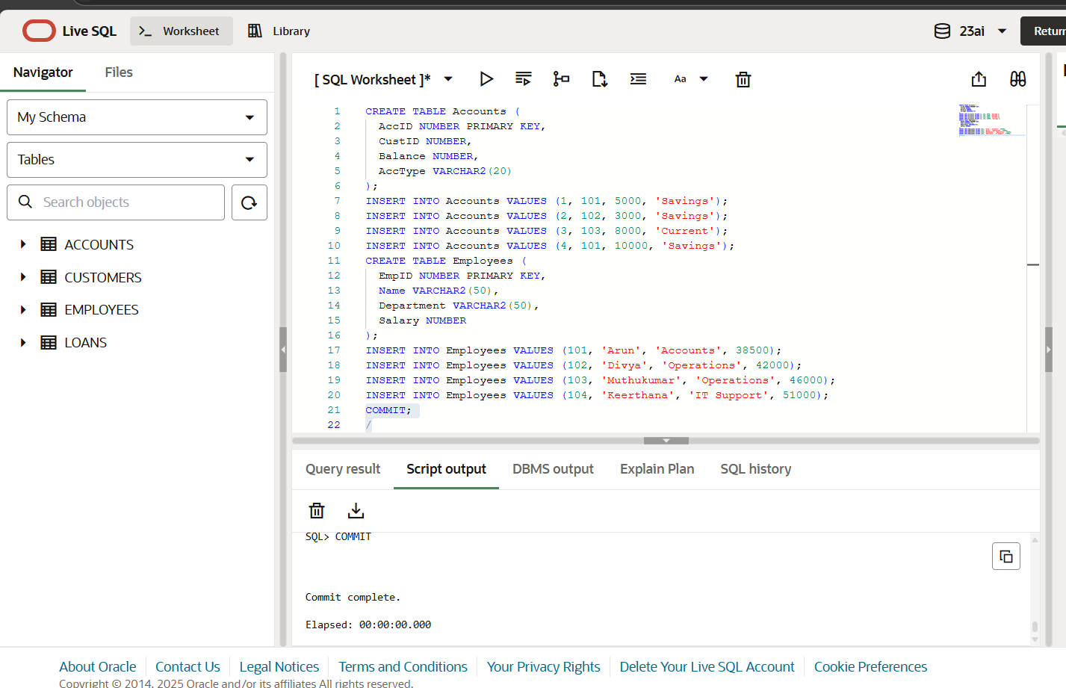

**Scenario 1 Implementation:**

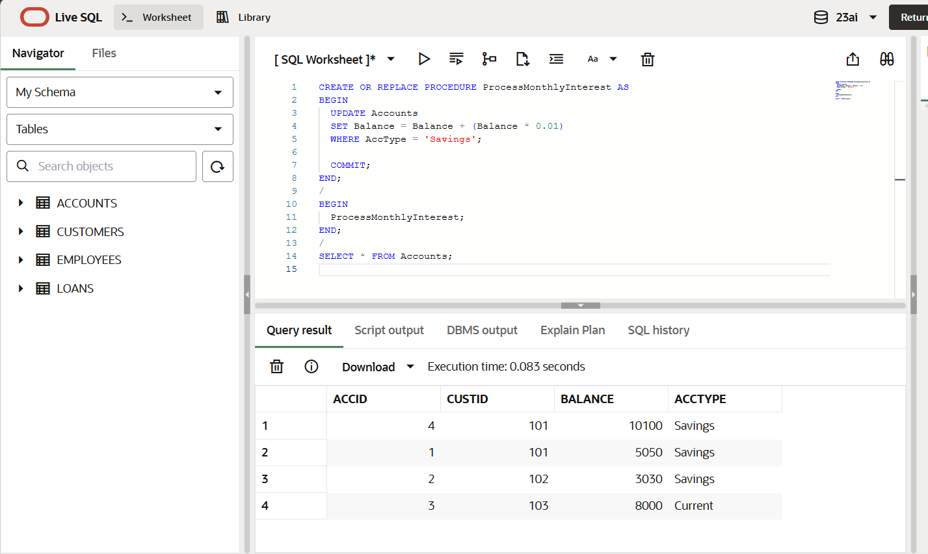

**Scenario 1 Output:**

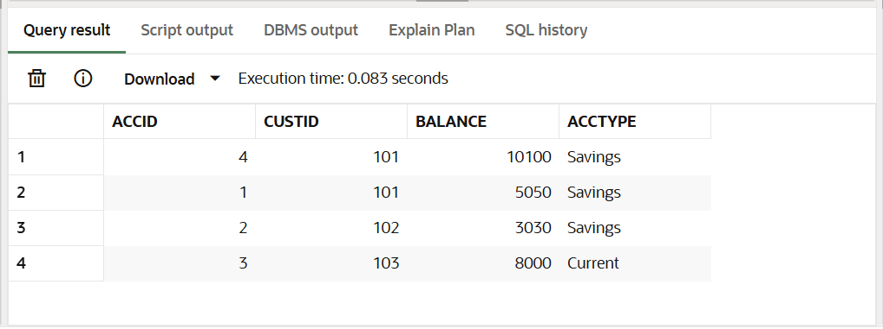

**Scenario 2 Implementation:**

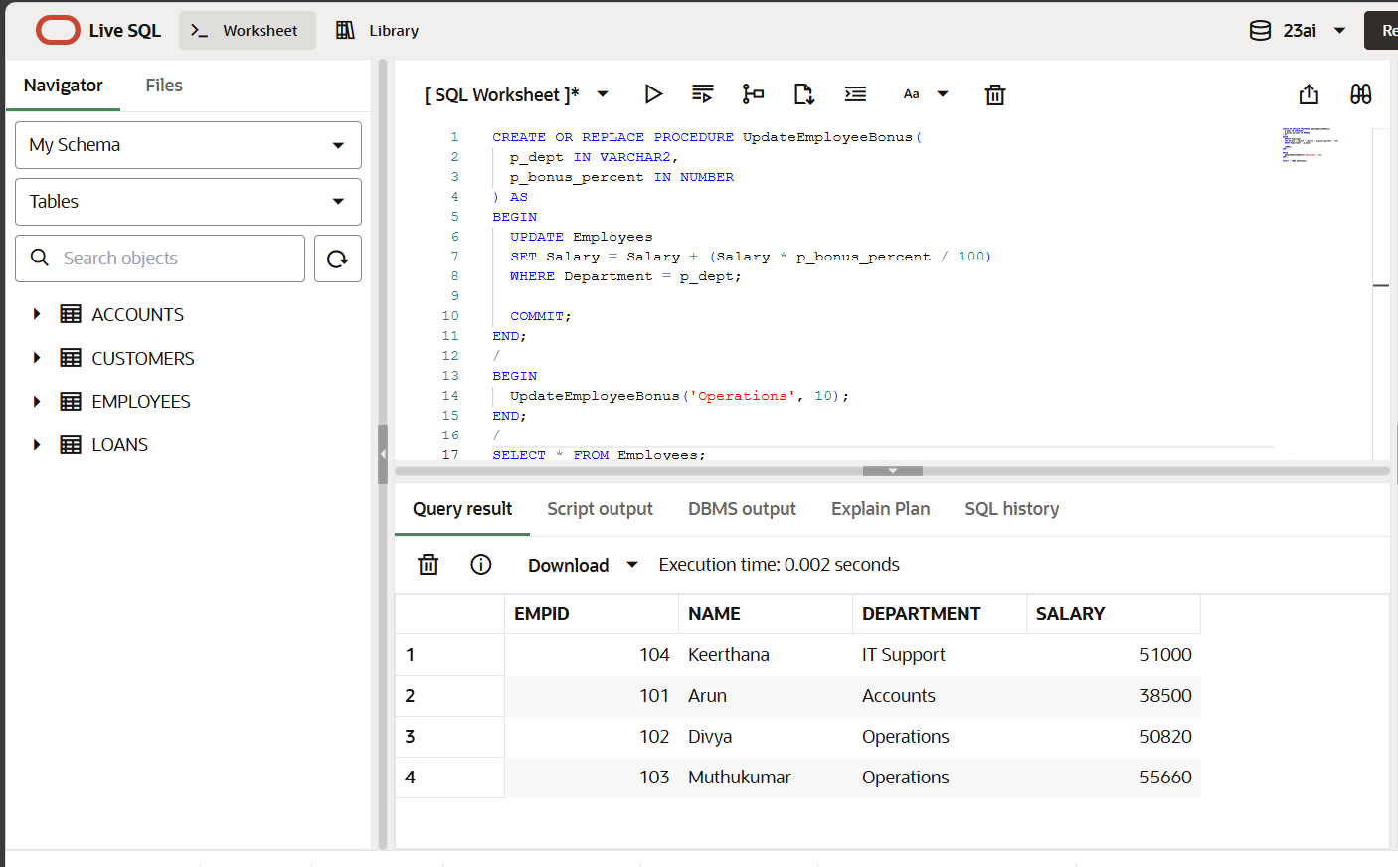

**Scenario 2 Output:**

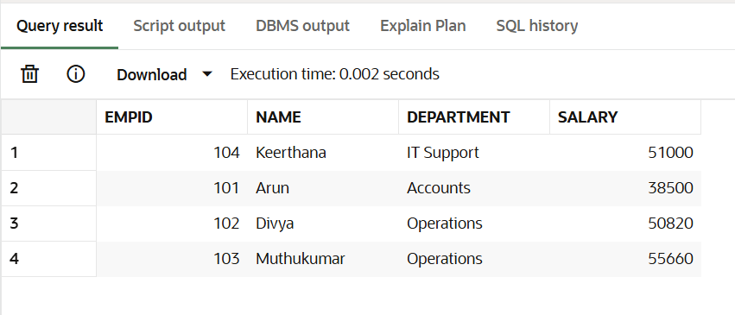

**Scenario 3 Implementation:**

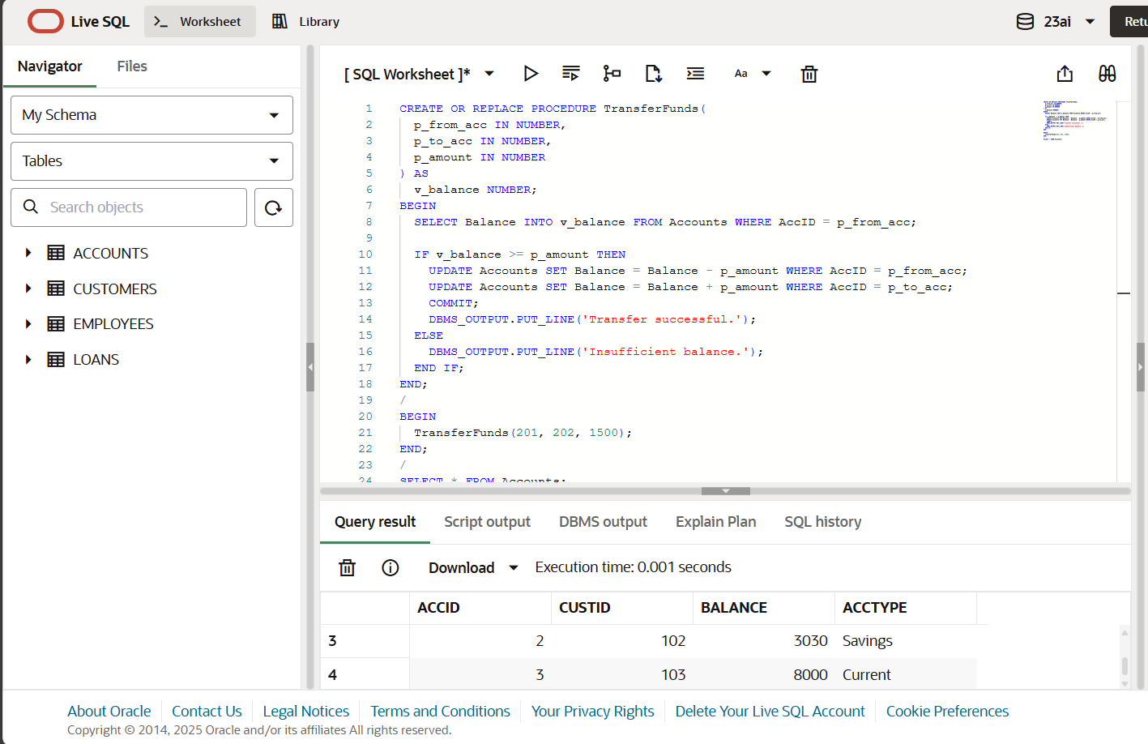

**Scenario 3 Output:**

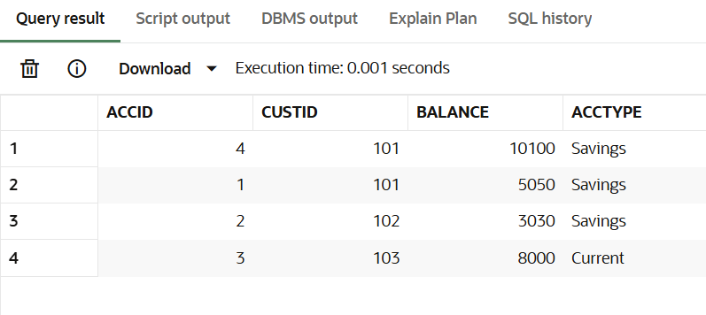

**PROGRAM :**

**Creation of tables and sample data :**

CREATE TABLE Accounts (

AccID NUMBER PRIMARY KEY,

CustID NUMBER,

Balance NUMBER,

AccType VARCHAR2(20)

);

INSERT INTO Accounts VALUES (201, 5001, 8450, 'Savings');

INSERT INTO Accounts VALUES (202, 5002, 6200, 'Savings');

INSERT INTO Accounts VALUES (203, 5003, 10250, 'Current');

INSERT INTO Accounts VALUES (204, 5001, 9700, 'Savings');

CREATE TABLE Employees (

EmpID NUMBER PRIMARY KEY,

Name VARCHAR2(50),

Department VARCHAR2(50),

Salary NUMBER

);

INSERT INTO Employees VALUES (101, 'Arun Prakash', 'Accounts', 38500);

INSERT INTO Employees VALUES (102, 'Divya Lakshmi', 'Operations', 42000);

INSERT INTO Employees VALUES (103, 'Muthukumar', 'Operations', 46000);

INSERT INTO Employees VALUES (104, 'Keerthana R.', 'IT Support', 51000);

COMMIT;

/

**Scenario 1 :**

CREATE OR REPLACE PROCEDURE ProcessMonthlyInterest AS

BEGIN

UPDATE Accounts

SET Balance = Balance + (Balance * 0.01)

WHERE AccType = 'Savings';

COMMIT;

END;

/

BEGIN

ProcessMonthlyInterest;

END;

/

SELECT * FROM Accounts;

**Scenario 2 :**

CREATE OR REPLACE PROCEDURE UpdateEmployeeBonus(

p_dept IN VARCHAR2,

p_bonus_percent IN NUMBER

) AS

BEGIN

UPDATE Employees

SET Salary = Salary + (Salary * p_bonus_percent / 100)

WHERE Department = p_dept;

COMMIT;

END;

/

BEGIN

UpdateEmployeeBonus('Operations', 8);

END;

/

SELECT * FROM Employees;

**Scenario 3 :**

CREATE OR REPLACE PROCEDURE TransferFunds(

  p_from_acc IN NUMBER,

  p_to_acc IN NUMBER,

  p_amount IN NUMBER

) AS

  v_balance NUMBER;

BEGIN

  SELECT Balance INTO v_balance FROM Accounts WHERE AccID = p_from_acc;

  IF v_balance >= p_amount THEN

    UPDATE Accounts SET Balance = Balance - p_amount WHERE AccID = p_from_acc;

    UPDATE Accounts SET Balance = Balance + p_amount WHERE AccID = p_to_acc;

    COMMIT;

    DBMS_OUTPUT.PUT_LINE('Transfer successful.');

  ELSE

    DBMS_OUTPUT.PUT_LINE('Insufficient balance.');

  END IF;

END;

/

BEGIN

  TransferFunds(201, 202, 1500);

END;

/

SELECT * FROM Accounts;

**OUTPUT :**

**Scenario 1:**



**Scenario 2 :**



**Scenario 3 :**

